Digital Alternatives to Hands-on Dissection
Simulations, animations, and video offer practical, safe, inexpensive, and effective ways to support anatomy instruction and to bring new technology into the classroom. An effective student-centered alternative to hands-on dissection, digital media allows students to engage in learning anatomy and dissection techniques in a virtual environment. Furthermore, research demonstrates that virtual dissection can be used as a pre-lab activity to improve student learning and to enhance the dissection experience.
Below, we provide corresponding Virginia Standards of Learning, a list of dissection-related resources arranged by organism and cross referenced by technology tool utilized, and a brief description of the potential uses of each resource.

Dissection in the Virginia Standards of Learning
These technology tools can be used to address several Virginia Standards of Learning for Life Science (7th grade) and Biology (High School). Online dissections are useful in lessons on levels of organization and classification (life science and biology) and human health and anatomy (biology).

2010 Science Standards of Learning (to be fully implemented in 2012-13)
Retrieved from: http://www.doe.virginia.gov/testing/sol/standards_docs/science/review.shtml
Goals:
3. Investigate phenomena using technology.
5. Experience the richness and excitement of scientific discovery of the natural world through the collaborative quest for knowledge and understanding.
8. Develop an understanding of the interrelationship of science with technology.
Instructional Technology
- Assist in improving every student’s functional literacy. This includes improved communication through reading/ information retrieval (the use of telecommunications).
- Technology... should also include computers [and] online communication.
Life Science
LS.1 The student will demonstrate an understanding of scientific reasoning, logic, and the nature of science by planning and conducting investigations in which
d) models and simulations are constructed and used to illustrate and explain
phenomena;
LS.4 The student will investigate and understand how organisms can be classified. Key concepts include
c) the distinguishing characteristics of major animal phyla
Biology
BIO.1 The student will demonstrate an understanding of scientific reasoning, logic, and the nature of science by planning and conducting investigations in which
a) observations of living organisms are recorded in the lab and in the field;
BIO.4 The student will investigate and understand life functions of Archaea, Bacteria and Eukarya. Key concepts include
c) how the structures and functions vary among and within the Eukarya kingdoms of
protists, fungi, plants, and animals, including humans;
d) human health issues, human anatomy, and body systems
BIO.6 The student will investigate and understand bases for modern classification systems. Key concepts include
a) structural similarities among organisms;
c) comparison of developmental stages in different organisms

2004 Science Standards of Learning (“old standards”)
Retrieved from: http://www.doe.virginia.gov/testing/sol/standards_docs/science/index.shtml

Life Science
LS.3 The student will investigate and understand that living things show patterns of cellular organization. Key concepts include
a) cells, tissues, organs, and systems; and
b) life functions and processes of … tissues, organs, and systems (respiration, removal of wastes, growth, reproduction, digestion, and cellular transport)
LS.5 The student will investigate and understand how organisms can be classified. Key concepts include
b) the distinguishing characteristics of major animal and plant phyla
Biology
BIO.1 The student will plan and conduct investigations in which
a) observations of living organisms are recorded in the lab and in the field
BIO.5 The student will investigate and understand life functions of archaebacteria, monerans (eubacteria), protists, fungi, plants, and animals including humans. Key concepts include
a) how their structures and functions vary between and within the kingdoms;
e) human health issues, human anatomy, body systems, and life functions
BIO.7 The student will investigate and understand bases for modern classification systems. Key concepts include
a) structural similarities among organisms;
c) comparison of developmental stages in different organisms

Collection of Dissection Related Resources

Title | Simulation | Animation | Video | Images
Cockroach Dissection (Microscopy UK) |  |  |  | X
Salmon Dissection (ThinkQuest) | X
Owl pellet, Squid, and Frog Dissection (Froguts) $ | X
Owl pellet | X
Net Frog Dissection (Univ. of Virginia) | X
Virtual Frog Dissection (McGraw-Hill) |  | X | X
Frog Dissection (Emantras, Inc) $ | X
Dissecting a Frog (Froguts) | X
Fetal Pig Dissection (Whitman College) | X
Cat Dissection (ThinkQuest) |  |  | X | X
Internal Anatomy of a Sheep Heart (Gateway CC) |  |  |  | X
Sheep Brain Dissection (Exploratorium) |  |  |  | X
Cow Eye Dissection (Exploratorium) |  |  | X
Virtual Eye Dissection (eSchool Online) | X
The Virtual Body (Medtropolis) |  | X |  | X
Body Maps (Healthline) |  |  |  | X
The Human Body: A dissection (Oddee) |  |  |  | X
The eSkeletons Project (Univ. of Texas) |  | X | X | X
$ Available for fee

https://www.msu.edu/course/cep/816/wallacespring02/dissection.htm
http://www.frogsarecool.com/choices.htm

NOTE: You may need the following software to run these simulations:
Java Runtime Environment: http://www.java.com
Macromedia Flash Player: http://www.macromedia.com/software/flash/about/
Macromedia Shockwave Player: http://sdc.shockwave.com/shockwave/download/download.cgi

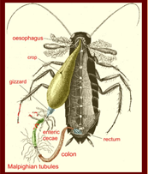 |  |  |  | Cockroach Dissection  http://www.microscopy-uk.org.uk/mag/indexmag.html?http://www.microscopy-uk.org.uk/mag/artaug05/wdparasite3.html  This website provides images and description of a cockroach dissection. The images are of real cockroaches. This would be useful to explore local fauna and to observe the anatomy of insects.
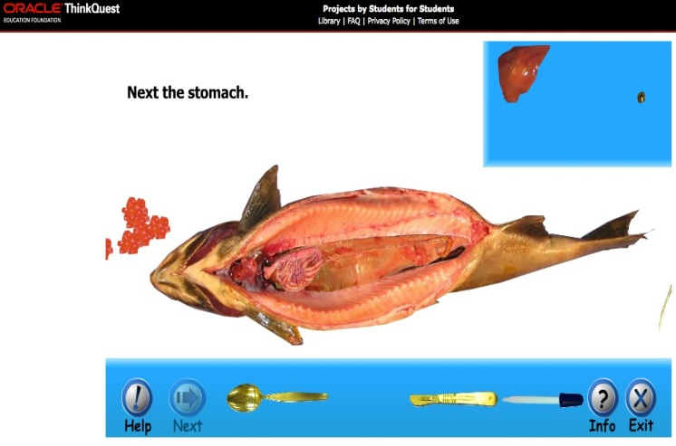 |  |  |  | Salmon Dissection  http://library.thinkquest.org/05aug/00548/DissectionGame.html  This interactive website allows students to explore the anatomy of fish through simulated dissection. This would be a good simulation to explore local fauna if there are salmonids in your local streams. The dissection simulation is done on a real fish. There is also an accompanying PowerPoint to supplement the simulation.
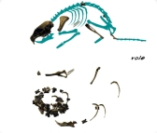 |  |  |  | Owl Pellet, Squid, and Frog Dissection  http://www.froguts.com/flash_content/index.html  This commercial site offers owl pellet, squid, and frog dissection simulations. A free owl pellet demonstration allows the student to click and drag bones from the pellet to the outline of the vole. The name of each skeletal piece is provided. This activity would be a good precursor to the actual dissection, which is a much messier activity! Click “demos” to see the free portions of the site.
Owl Pellet Dissection
http://www.kidwings.com/owlpellets/flash/v4/index.htm
Contains digital images of owl pellets from different species of owls. Clicking on the images provides close up images of bones that ultimately let students infer what animal the owl ate.
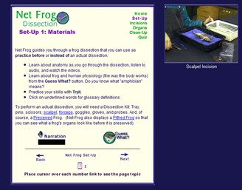 |  |  |  | Net Frog Dissection  http://frog.edschool.virginia.edu/  A self-paced virtual tour of a frog dissection, this free site allows a student to view each step of the dissection process, along with certain steps in which a student can interact with images to assess understanding and provide immediate feedback.
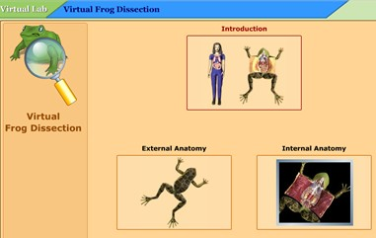 |  |  | Virtual Frog Dissection  http://www.mhhe.com/biosci/genbio/virtual_labs/BL_16/BL_16.html  This site contains a collection of videos and animations about a frog’s external and internal anatomy. The videos show a demonstrator dissecting a real frog as the narration guides the viewer. The videos can be used as an introduction to a frog dissection so students know what to expect and look for, or as a substitution to a real frog dissection.
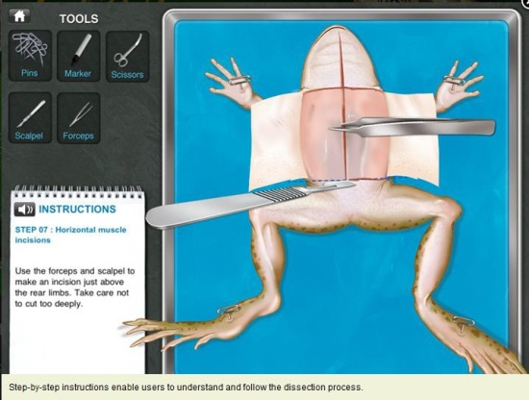 |  |  | Frog Dissection by Emantras Inc  http://itunes.apple.com/us/app/frog-dissection/id377626675?mt=8 http://frogvirtualdissection.com/  This is an award-winning application (“app”) usable on a computer or iPad. Its normal price is $3.99, but it may be available with an educational discount.  A video demonstration of the app is available here: http:// www.youtube.com/watch?v=uonZSFg9xTE.
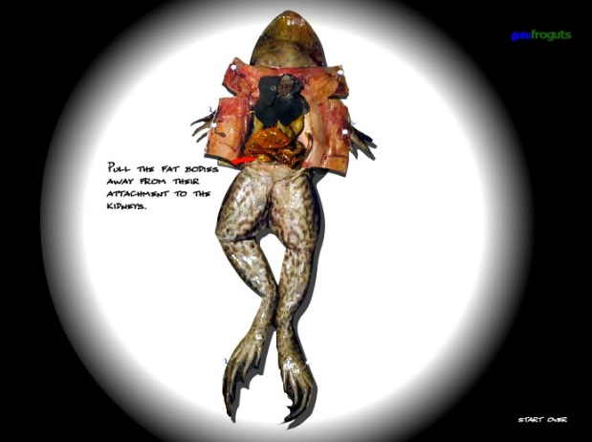 |  |  | Dissecting a Frog Simulation  http://www.surgery-games.org/43/Dissect-a-Frog.html  This exciting simulation walks students through the steps of dissecting a frog, while requiring them to select and use appropriate dissecting tools. After successfully opening the frog, students identify the major organs to complete the simulation. This site can be used as an introduction to dissection and to familiarize students with the use of dissection tools.
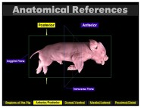 |  |  | Fetal Pig Dissection  http://www.whitman.edu/biology/vpd/main.html  Not for the weak-kneed, this virtual dissection activity takes the student through six body systems of the fetal pig. The images are clear and life-like, and the student interacts by clicking through each step. The six systems can be done all at once or individually (revisiting the site each unit if systems are covered with one system per unit). This site also has quizzes after each section of the activity.
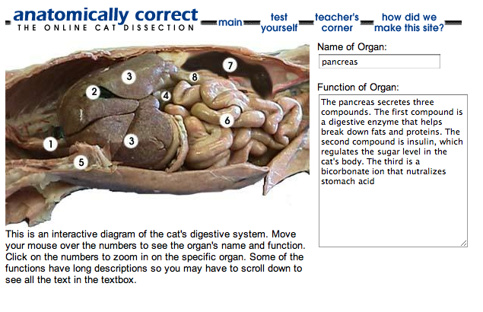 |  | Cat Dissection  http://library.thinkquest.org/15401/  This site provides students with interactive photos of the respiratory, uro-genital, and digestive system of cats. Whether to review body systems or to complete a lab exercise, students can hold the mouse over various parts of the systems in order to learn more about the organs. To further enhance their experience, students can view videos of cat dissections, take quizzes, or view a list of definitions. The site offers printable diagrams, worksheets, and quizzes for teachers.
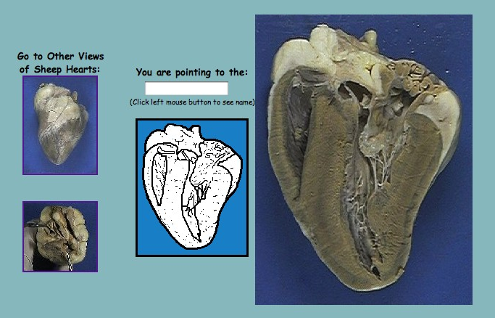 |  | Internal Anatomy of a Sheep Heart  http://www.gwc.maricopa.edu/class/bio202/cyberheart/inthrt.htm  Offering real photos of a sheep heart, this site allows students to click anywhere on the photos to identify parts of the anatomy. This site is a particularly helpful reference tool if students are dissecting a sheep heart and are having problems identifying its numerous parts. It can also serve as a review tool for students after they have virtually or realistically dissected a sheep heart.
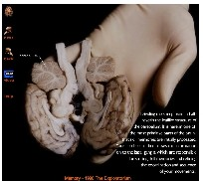 |  | Sheep Brain Dissection  http://www.exploratorium.edu/memory/braindissection/index.html  Real photos of a sheep brain with captions on the side, walk the viewer through the parts of the brain that are associated with memory and cognition. Showing a simple dissection of the brain, the photos and captions provide concise information about the major parts of a brain. This site is useful as an extension for an introductory lesson about the brain and/or memory.
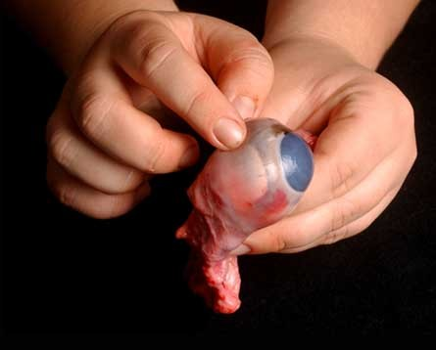 | Cow Eye Dissection  http://www.exploratorium.edu/learning_studio/cow_eye/index.html  This site provides a series of videos (about 40 seconds each) showing the dissection of a cow’s eye. The second element is an interactive diagram that could be used for student-centered investigation or whole-class overview. Lastly, the site provides a lab manual for an actual eye dissection.
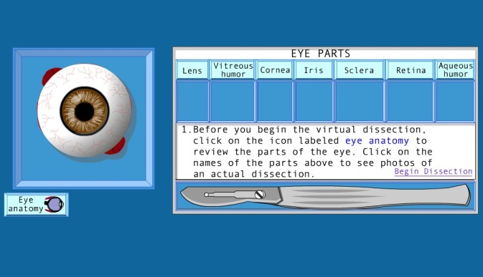 | Virtual Eye Dissection:  The Anatomy of the Eye  http://www.eschoolonline.com/company/examples/eye/eyedissect.html  This interactive site involves an animated simulation of an eye dissection. Students are asked to identify the different parts of the eye multiple times. It is a model of a human eye and would be good for a unit on the senses or anatomy of humans.
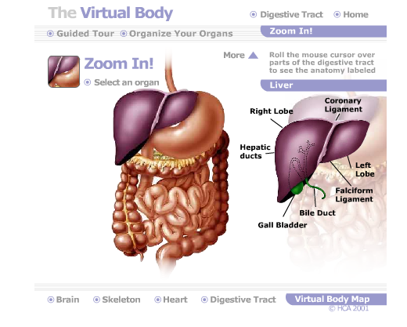 | The Virtual Body  http://www.medtropolis.com/VBody.asp  This interactive site offers students a multitude of activities to learn about the human brain, skeleton, heart, and digestive tract. With interactive diagrams, narrated animations, and rebuilding the systems games, this site provides students with an opportunity to learn details about the organs and to test themselves on what they have learned.
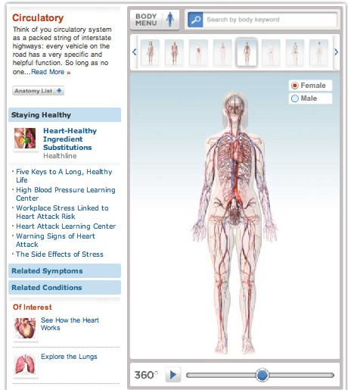 | Body Maps  http://www.healthline.com/human-body-maps#3/1  This site provides rotating 3D images of the human body. It also provides a rotating image of each body system. With each system are detailed descriptions of the body system as well as common problems with the specific body system. There is also an anatomy list of organs associated with each system. By highlighting the organ name, the organ is highlighted on the body and you are provided a description of the organ’s function.
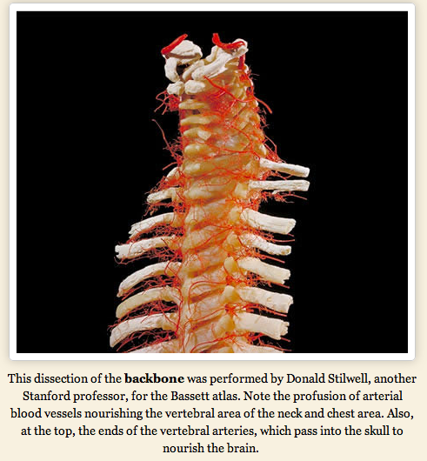 | The Human Body: A Dissection  http://www.oddee.com/item_96547.aspx  This site provides real life images of a human cadaver. There are detailed pictures including the nervous system, circulatory system, skeletal system, and the muscular system. After each picture there is an explanation about each picture.
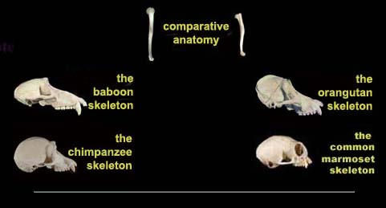 | The eSkeletons Project  http://www.eskeletons.org/  This interactive site allows participants to learn about skeletal anatomy by viewing the bones of a human, chimpanzee, and baboon. The Comparative Anatomy section enables users to make direct comparisons.

